Assignment: Network Security, Maintenance, and Troubleshooting Procedures

**Submitted By :- Purv Patel**

**Section 1: Multiple Choice**

1. What is the primary purpose of a firewall in a network security infrastructure?

= b) Filtering and controlling network traffic

2. What type of attack involves flooding a network with excessive traffic todisrupt normal operation?

= a) Denial of Service (DoS)

3. Which encryption protocol is commonly used to secure wireless networkcommunications?

= b) WPA (Wi-Fi Protected Access)

4. What is the purpose of a VPN (Virtual Private Network) in a network securitycontext?

= a) Encrypting network traffic to prevent eavesdropping

**Section 2: True or False**

5. True or False: Patch management is the process of regularly updatingsoftwareand firmware to address security vulnerabilities and improve systemperformance.

= True.

Patch management is indeed the process of regularly updating software and firmware to address security vulnerabilities and improve system performance.

6. True or False: A network administrator should perform regular backups of critical data to prevent data loss in the event of hardware failures, disasters, orsecurity breaches.

= True.

Regular backups of critical data are essential to prevent data loss in the event of hardware failures, disasters, or security breaches.

7. True or False: Traceroute is a network diagnostic tool used to identify theroute and measure the latency of data packets between a source anddestination device.

= True.

Traceroute is indeed a network diagnostic tool used to identify the route and measure the latency of data packets between a source and destination device.

**Section 3: Short Answer**

8. Describe the steps involved in conducting a network vulnerability Assignment.

= Conducting a network vulnerability assessment involves several key steps to identify, analyze, and mitigate potential vulnerabilities in a network. Here's an overview of the typical process:

1. Planning and Scoping:

2. Asset Identification:

3. Vulnerability Scanning:

4. Manual Assessment:

5. Prioritization and Risk Assessment:

6. Remediation Planning:

7. Reporting and Documentation:

of addressing identified vulnerabilities.

8. Follow-Up and Continuous Improvement:

**Section 4: Practical Application**

9. Demonstrate how to troubleshoot network connectivity issues using the ping command

=

1. Open a command prompt or terminal window on your computer.

2. Type `ping` followed by the IP address or domain name of the target device or website you want to test connectivity to.

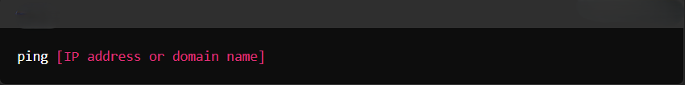

For example:



Or:

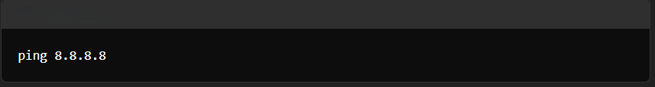

3. Press Enter to execute the command.

4. The `ping` command will send ICMP (Internet Control Message Protocol) echo request packets to the target device or website and wait for a response.

5. You will see the following information:

- The IP address of the target device or website being pinged.

- The number of bytes of data being sent in each packet (typically 32 bytes).

- The time it takes for each packet to travel to the target device or website and back (round-trip time or RTT), measured in milliseconds (ms).

6. You will also see the following statistics:

- Packets Sent: The number of ICMP echo request packets sent.

- Packets Received: The number of ICMP echo reply packets received.

- Packet Loss: The percentage of packets lost during transmission.

- Minimum, Maximum, and Average RTT: The minimum, maximum, and average round-trip times for successful packets.

7. If you receive responses from the target device or website, it indicates that there is connectivity between your computer and the target.

8. If you encounter issues such as packet loss or high latency, it may indicate network connectivity problems. You can use the `ping` command with different IP addresses or domain names to test connectivity to other devices or websites and identify where the problem lies.

9. Press Ctrl + C to stop the `ping` command when you have gathered the necessary information.

**Section 5: Essay**

10. Discuss the importance of regular network maintenance and the key tasks involved in maintaining network infrastructure.

= Regular network maintenance is crucial for ensuring the reliability, security, and performance of network infrastructure. Here are some reasons why regular maintenance is important:

1. Preventive Maintenance: Regular maintenance helps identify and address potential issues before they escalate into major problems. By proactively monitoring and maintaining network devices, administrators can prevent downtime and minimize disruptions to business operations.

2. Security: Regular maintenance includes applying security patches, updates, and configurations to protect the network from vulnerabilities and cyber threats. Keeping network devices up-to-date with the latest security measures is essential for safeguarding sensitive data and preventing unauthorized access.

3. Performance Optimization: Network maintenance involves optimizing network configurations, monitoring traffic patterns, and tuning performance parameters to ensure optimal network performance. This includes identifying and resolving bottlenecks, optimizing bandwidth usage, and enhancing overall network efficiency.

4. Compliance Requirements: Many industries have regulatory compliance requirements that mandate regular network maintenance and security audits. By adhering to these requirements, organizations can avoid penalties, fines, and legal liabilities associated with non-compliance.

5. Resource Utilization: Regular maintenance helps ensure efficient utilization of network resources, such as bandwidth, storage, and computing resources. By monitoring resource usage and optimizing resource allocation, administrators can maximize the productivity and efficiency of the network infrastructure.

Key tasks involved in maintaining network infrastructure include:

1. Monitoring: Continuously monitor network performance, availability, and security using network monitoring tools and software. Monitor network traffic, device health, bandwidth utilization, and security events to identify issues and anomalies.

2. Patch Management: Regularly apply patches, updates, and firmware upgrades to network devices, including routers, switches, firewalls, and servers, to address security vulnerabilities and improve performance.

3. Configuration Management: Maintain accurate and up-to-date configurations for network devices to ensure consistency, security, and compliance with organizational policies. Implement configuration changes carefully and document changes to track configuration history.

4. Backup and Disaster Recovery: Regularly backup critical network configurations, device settings, and data to prevent data loss in the event of hardware failures, disasters, or security breaches. Test backup and recovery procedures regularly to ensure their effectiveness.

5. Security Audits and Assessments: Conduct regular security audits and vulnerability assessments to identify weaknesses in the network infrastructure. Perform penetration testing, vulnerability scanning, and security assessments to proactively identify and address security vulnerabilities.

6. User Training and Awareness: Educate users about security best practices, such as password management, phishing awareness, and data protection policies. Provide training and awareness programs to help users recognize and respond to security threats effectively.

7. Documentation and Documentation: Maintain comprehensive documentation of network configurations, topology, policies, procedures, and troubleshooting guides. Document network changes, incidents, and resolutions to facilitate knowledge sharing and troubleshooting.

By performing these key tasks regularly, organizations can ensure the reliability, security, and performance of their network infrastructure, thereby supporting business objectives and maintaining a competitive edge in today's digital landscape.